Name:

5th Grade CBA1 Review

1 | 5.3A
Robert has 9​​$\frac{1}{2}$ inches of green ribbon and 8$\frac{1}{5}$​​ inches of red ribbon. Jack gives him 7 inches of red ribbon. Approximately how much more red ribbon than green ribbon does Robert have now?
 | A. | 7 in.
 | B. | 5 in.
 | C. | 8 in.
 | D. | 10$\frac{3}{4}$ in.

2 | 5.3B
A play was held in a theater that can seat 376 people at one time. There were 15 performances of the play, and the theater was sold out for each performance. How many tickets to the play were sold?
 | A. | 2,256
 | B. | 5,310
 | C. | 5,640
 | D. | 6,260

3 | 5.3B
Alexis does 35 sit-ups every day of the year. There are 365 days in the year. How many sit-ups does she do in one year?
 | A. | 6,500
 | B. | 12,775
 | C. | 13,125
 | D. | 18,875

4 | 5.3C
To pay for a new saxophone, Henry is paying $24 each month. If he must pay a total of $1,392 how many months will it take Henry to pay for the saxophone?
 | A. | 1368
 | B. | 58
 | C. | 33,408
 | D. | 15

5 | 5.3C
Bonnie has lived in Texas for 1068 months. How many years has she lived in Texas?
Record your answer and fill in the bubbles on the grid below. Be sure to use the correct place value.

.

6 | 5.3K
Penn has a board that is 8$\frac{5}{6}$ feet long. He cuts a piece off of the board that is 3 $\frac{1}{4}$ feet long. How long is the remaining piece of board?
 | A. | 4$\frac{5}{12}$ feet
 | B. | $5\frac{5}{12}$ feet
 | C. | 5$\frac{7}{12}$ feet
 | D. | 3 $\frac{7}{12}$feet

7 | 5.3K
Sophia has $2\frac{3}{4}$ yards of blue fabric, 4 $\frac{2}{3}$ yards of green fabric and $6\frac{2}{3}$ yards of yellow fabric that she will use to make curtains. How many yards of blue and green fabric does Sophia have?
 | A. | 1 $\frac{11}{12}$
 | B. | 6 $\frac{11}{12}$
 | C. | 7$\frac{5}{12}$
 | D. | 14$\frac{1}{2}$

8 | 5.3H
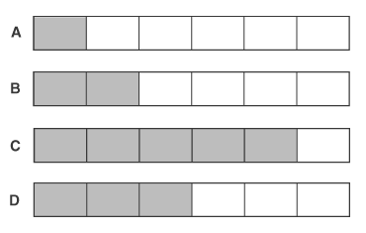

Which diagram shows the solution to the expression $\frac{7}{8}-\frac{13}{24}?$
 | A. | Diagram A
 | B. | Diagram B
 | C. | Diagram C
 | D. | Diagram D

9 | 5.4H
An isosceles triangle has two sides each 2$\frac{3}{4}$ inches and a third side that is 1$\frac{1}{2}$ inches. What is the perimeter of the triangle?
 | A. | $\frac{3}{4}$ inch
 | B. | 4$\frac{1}{4}$ inches  2$\frac{3}{4}$ in  2$\frac{3}{4}$ in
 | C. | 8$\frac{1}{2}$ inches
 | D. | 7 inches  1$\frac{1}{2}$ in

10 | 5.4A
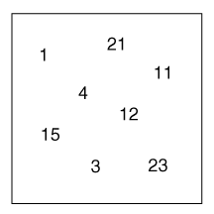

Look at the numbers in the box.
Which of the numbers make up a set of prime numbers?
 | A | 3, 11, 23
 | B. | 1, 3, 23
 | C. | 1, 3, 13
 | D. | 3, 15, 23

11 | 5.4B
Each week Peggy earns $28 working at a craft shop. She then spends $15 for her lunches and $7 to rent videos. Peggy saves the rest of her money each week. Which expression could be used to find how much money Peggy saves after w weeks?
 | A. | w (28 – 15 + 7)
 | B. | w (28 + 15 – 7)
 | C. | w (28) – w (8)
 | D. | w [28 – (15 + 7)]

12 | 5.4B
Kelly earns $15 per week for 4 weeks. She gives her brother $8 and divides the rest of the money, m, into three different accounts. Which equation represents how much money Kelly deposited into each account?
 | A. | 15 × 4 − 8 = m
 | B. | 15 × 4 + 8 = m
 | C. | (15 × 4 − 8) ÷ 3 = m
 | D. | (15 × 4 − 8) × 3 = m

13 | 5.4E
Look at this numeric expression:
(2 + 3) × (7 – 4) ÷ (5 – 2)
Why are the parenthesis used?
 | A. | To show numbers that should be added
 | B. | To show operations that should be completed first
 | C. | To show numbers that should be multiplied
 | D. | To show operations that are unusual

14 | 5.4F
Simplify this numerical expression:
[(3 + 8) × (2 + 4)] – 3 =
 | A. | 20
 | B. | 23
 | C. | 33
 | D. | 63

15 | 5.4F
What is the value of this expression?
36 ÷ (20 − 2) × (7 + 3) × 6

Record your answer and fill in the bubbles on the grid.
Be sure to use the correct place value.

.

16 | 5.3H
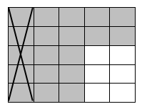

Which expression is represented by the model?
 | A. | $\frac{6}{25}$ - $\frac{1}{5}$
 | B. | $\frac{9}{20}$ - $\frac{5}{20}$
 | C. | $\frac{6}{19}$ - $\frac{5}{19}$
 | D. | $\frac{19}{25}$ - $\frac{1}{5}$

