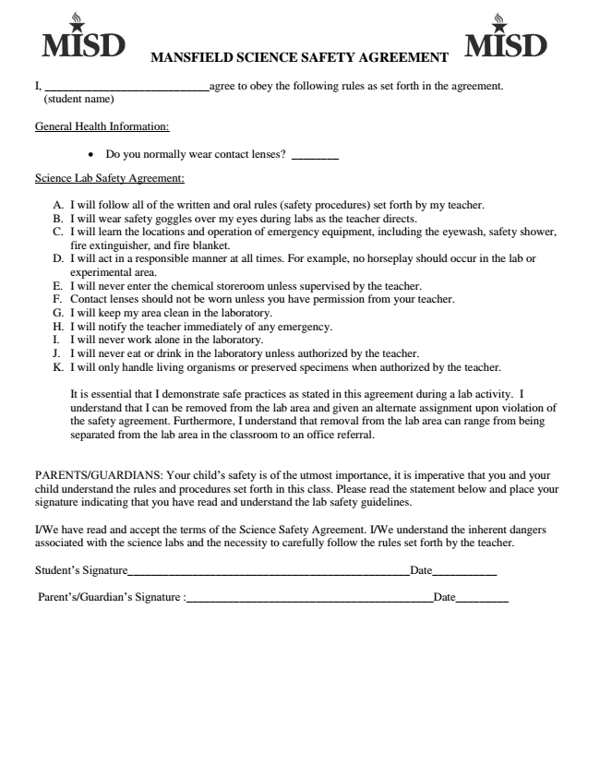
MANSFIELD SCIENCE SAFETY AGREEMENT
I, ____________________________agree to obey the following rules as set forth in the agreement.
(student name)
General Health Information:
• Do you normally wear contact lenses? ________
Science Lab Safety Agreement:
A. I will follow all of the written and oral rules (safety procedures) set forth by my teacher. B. I will wear safety goggles over my eyes during labs as the teacher directs. C. I will learn the locations and operation of emergency equipment, including the eyewash, safety shower,
fire extinguisher, and fire blanket. D. I will act in a responsible manner at all times. For example, no horseplay should occur in the lab or
experimental area. E. I will never enter the chemical storeroom unless supervised by the teacher. F. Contact lenses should not be worn unless you have permission from your teacher. G. I will keep my area clean in the laboratory. H. I will notify the teacher immediately of any emergency. I. I will never work alone in the laboratory. J. I will never eat or drink in the laboratory unless authorized by the teacher. K. I will only handle living organisms or preserved specimens when authorized by the teacher.
It is essential that I demonstrate safe practices as stated in this agreement during a lab activity. I understand that I can be removed from the lab area and given an alternate assignment upon violation of the safety agreement. Furthermore, I understand that removal from the lab area can range from being separated from the lab area in the classroom to an office referral.
PARENTS/GUARDIANS: Your child’s safety is of the utmost importance, it is imperative that you and your child understand the rules and procedures set forth in this class. Please read the statement below and place your signature indicating that you have read and understand the lab safety guidelines.
I/We have read and accept the terms of the Science Safety Agreement. I/We understand the inherent dangers associated with the science labs and the necessity to carefully follow the rules set forth by the teacher.
Student’s Signature________________________________________________Date___________
Parent’s/Guardian’s Signature :__________________________________________Date_________

